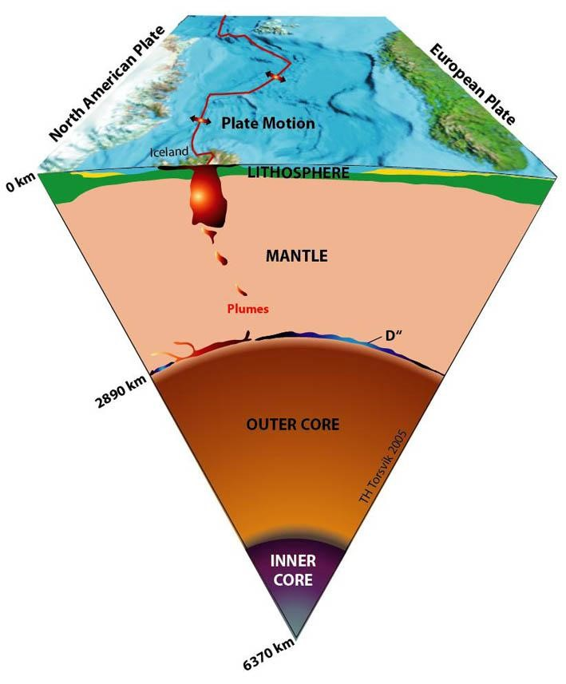
THE STRUCTURE OF THE EARTH

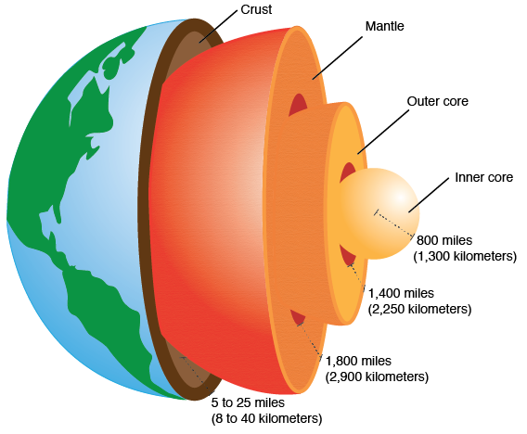

Refer to the information above to answer the questions.
Layer of the Earth | Estimated  Thickness  (kilometres) | State | Estimated  Temperature  (ºC)
Crust | 8 to 64 | Solid and rigid | 20 to 500
Mantle | 2900 | Solid but  plasticine - like | 500 to 2000
Outer Core | 2200 | Liquid | 3000
Inner Core | 1300 (radius) | Solid | 4000

- The crust on which we stand varies in thickness from 8 km to 64 km. Would the crust be thickest under continents (such as Australia and Europe) or under the oceans?

- The continents are situated on crustal plates that can move. What feature or property of the mantle allows movement of the earth’s crust to occur?

- The outer core is liquid (molten rock). However the inner core which is hotter than the inner core is thought to be solid. How is this possible?

- The table above shows the depths and temperatures recorded in a mine shaft.
Depth (km) | Temperature (ºC)
0 | 20
1 | 51
2 | 82
3 | 112
4 | 142
5 | 171
6 | 201
7 | 230

- Plot the data on the scatterplot below and draw a trend line through the dots. The independent variable is the depth, the dependent variable is the temperature. This means you should put the depth on the horizontal axis and the temperature on the vertical axis. Make the depth axis go to 20 kms, and the temp axis from 0 to 500 ⁰C.

- Extrapolate (extend) your trend line and use it to predict the temperature at the depths of 8 km and 20 km.

- The deepest current mine is less than 10 kilometres deep. How do you think geologists (scientists who study earth movements and rocks) estimate the thickness and temperature of the layers of the earth?
500
 |  |  |  |  |  |  |  |  |  |  |  |  |  |  |  |  |  |  |  | 2 | 0

www.qldscienceteachers.com

